**Game Name:** FALLEN ANGEL

**Objective:** To survive, retrieve a flare and ignite it for rescue.

**Story:**

1980, Russia. The war between the Soviet’s and the Rural men is currently at its peak. The local general is requesting for those able to enlist and fight for your country. ‘Sounds good’ you thought as you went on to enter the ranks of the Russian Army.

After a couple weeks you are stationed in a compound near the region of conflict. You’ve been trained as a pilot with an upcoming patrol mission. You’ve been trained well so you’re confident it will be a breeze.

Night pass and its finally the day to put your training to the test. You tighten the straps of your leather helmet and position yourself in the Sukhoi-17 fighter plane. With the signal given you fly out in to the air and begin your mission.

You admire the vast mountains the region has to offer as you are undergoing your patrol. The snow-peaked mountains captivate you as you fail to notice you are veering off your given flight path.

A blast would take out one of the wings. You are under attack. The console begins to flood out various signals and alarms as your try your best to maintain control of the aircraft. With only 2/3 of the plane still in-tact, it begins to nose-dive at a manic speed. Your visor begins to fog as you descend at an incredible rate. Unaware, confused and in panic, you shut your eyes and brace for impact.

**Scenario:**

You awake to find yourself laying in a desert, surrounded by metal debris. Shards of what looks to be remnants of a plane can be seen scattered in the sand. You are mildly wounded.

The hot sun is staring at you as you try to recollect how you ended up here.

You notice your uniform is slightly torn and your survival gear completely ruined.

Beside you are some belongings of yours, including a battle rifle, bottle of water and some papers.

You must find help before its too late. Good luck.

**Options available**

TAKE – Take an item  
FIRE – Fires the weapon  
DRINK – Drinks <item> if available  
WALK <direction> - Walks player to a direction of <North/East/South/West>  
MAP – Prints somewhat of a map  
CHECK AMMO – Checks ammunition out of /5  
 **∟**If ammo is below 1, it should auto reload.  
DROP- Drops <item>  
POCKETS – Reveals inventory  
EASYWAYOUT- Quits with message [“You point the barrel of your gun against your temple and follow through to heaven”]  
EXAMINE – Examines <item>

**Locations**

CRASH SITE  
OUTPOST  
CAMP  
ENDLESS ROAD  
MARKET  
RUINS  
AMBUSHED CITY  
THE LAKE

**Map**

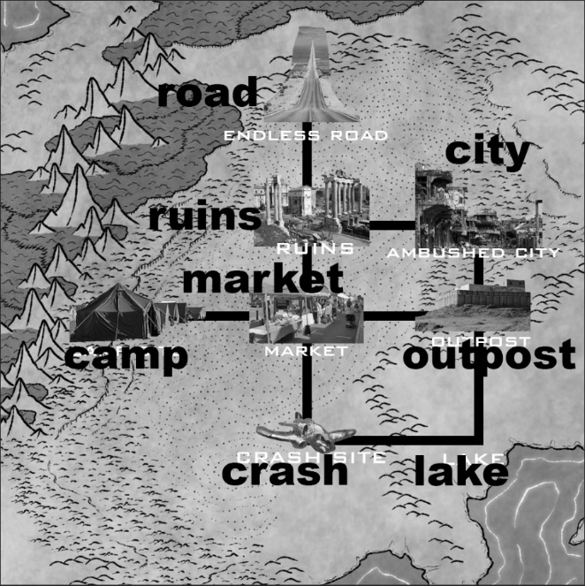

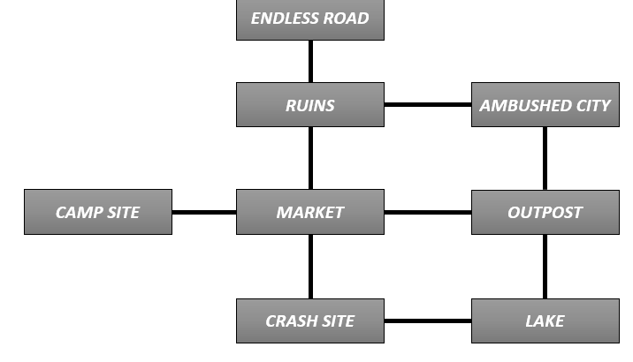

**Items**

|  |  |
| --- | --- |
| Item | Description |
| BATTLE RIFLE 1 | AK-74 (5.45x39mm) |
| BATTLE RIFLE 2 | AK47-S (7.62x39mm) |
| BATTLE RIFLE 3 | M16A1 (5.56mm) |
| PISTOL | Tokarev (.30 Bore) |
| BREAD | Simple food |
| MAP | n/a |
| AMMUNITION | A handful of bullets left in a greasy rag. |
| RATIONS | Special issue packet food. Won’t taste great but it does the trick. |

|  |  |
| --- | --- |
| Location | Items Available |
| CRASH SITE | BATTLE RIFLE  BREAD  MAP |
| OUTPOST | AMMUNITION  PISTOL  BATTLE RIFLE 2  RATIONS |
| CAMP | ( SCENIC ) |
| ENDLESS ROAD | ( SCENIC ) |
| MARKET | FOOD |
| RUINS | ROCKS (ONLY TO PICK AND DROP NOT TAKE)_ |
| AMBUSHED CITY | KNIFE  BATTLE RIFLE  BATTLE RIFLE  BATTLE RIFLE |
| THE LAKE | WATER  (POSSIBLY SCRIPTED PERSON TO TALK WITH) |

**Items Location**